UL 10064 FEP or PFA Hook Up Wire
Product Description：
● Conductor: Soild or Standed, Bare/ Tin/ Sliver Plated copper
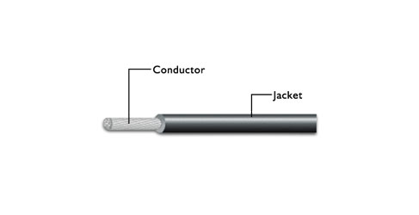
● Insulation: FEP or PFA
Construction：

General Cable
Application：
For internal wiring of electronic appliances

UL Style | Conductor |  | Insulation Thickness | Overall Diameter
UL Style | AWG | No./mm | mm | mm
UL10064 | 38 | 7/004 | ≧0.05 | 0.23±0.02
UL10064 | 36 | 7/0.05 | ≧0.05 | 0.26±0.02
UL10064 | 35 | 7/0.06 | ≧0.05 | 0.29±0.02
UL10064 | 34 | 7/0.07 | ≧0.05 | 0.32±0.03
UL10064 | 32 | 7/0.08 | ≧0.05 | 0.35±0.03
UL10064 | 30 | 7/0.10 | ≧0.05 | 0.41±0.04
UL10064 | 28 | 7/0.12 | ≧0.05 | 0.47±0.04
UL10064 | 26 | 7/0.16 | ≧0.05 | 0.60±0.04
UL10064 | 24 | 7/0.20 | ≧0.05 | 0.73±0.05
UL10064 | 22 | 7/0.254 | ≧0.05 | 0.89±0.06

